Day 7: Understanding package manager and systemctl

# What is a package manager in Linux?

In simpler words, a package manager is a tool that allows users to install, remove, upgrade, configure and manage software packages on an operating system. The package manager can be a graphical application like a software center or a command line tool like apt-get, YUM or pacman.

# What is a package?

A package is usually referred to an application but it could be a GUI application, command line tool or a software library (required by other software programs). A package is essentially an archive file containing the binary executable, configuration file and sometimes information about the dependencies.

# Different kinds of package managers

Package Managers differ based on packaging system but same packaging system may have more than one package manager.

For example, RPM has Yum and DNF package managers. For DEB, you have apt-get, aptitude command line based package managers.

## Task 1 : You have to install docker and jenkins in your system from your terminal using package managers

**Commands used to install Docker and Manage Docker :**

1. Remove any Docker files that are running in the system, using the following command:

$ sudo yum remove docker docker-engine docker.io

1. Check if the system is up-to-date using the following command:

$ sudo yum update

1. Install Docker using the following command:

yum install docker

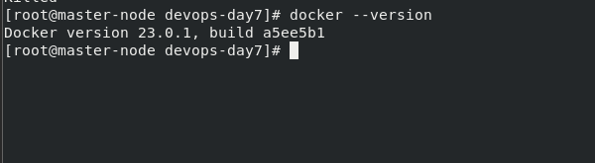

1. Before testing Docker, check the version installed using the following command:

$ docker --version



6 . Pull an image from the Docker hub using the following command:

$ sudo docker run hello-world

Here, *hello-world* is the docker image present on the Docker hub.

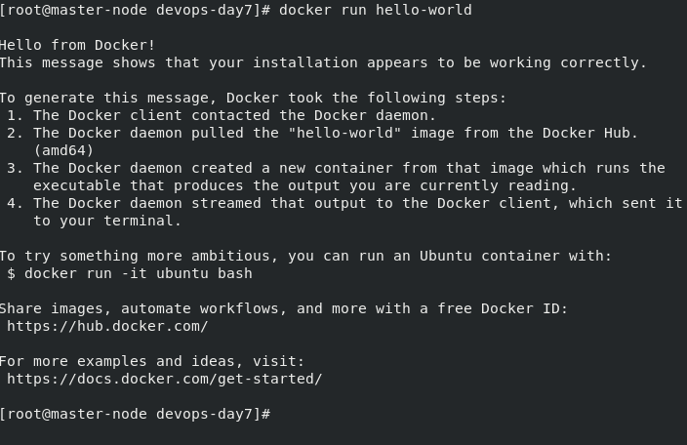

1. Check if the docker image has been pulled and is present in your system using the following command:

$ sudo docker images

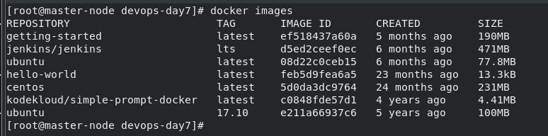

1. To display all the containers pulled, use the following command:

$ sudo docker ps -a



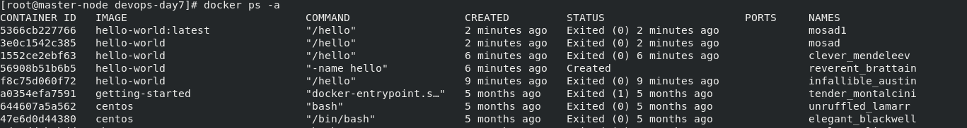

Now docker installed Well !!

## Install Jenkins:-

Check the below website for step by step installation of Jenkins on your Centos server.

[How To Install Jenkins On CentOS 7 With 5 Steps (azdigi.com)](https://azdigi.com/blog/en/linux-server-en/tools-en/how-to-install-jenkins-on-centos-7/)

# What is systemctl and systemd ?

systemd is a Linux init system and system manager that is widely used in modern Linux distributions as the default init system. It provides a way to manage and control the various services that run on a Linux system, as well as other system-level functionality.

systemctl is the command line tool used to control and manage the systemd system and service manager. It provides various commands to start, stop, restart, enable, and disable services, as well as other functionalities such as inspecting the status of services, displaying log messages, and managing system-level settings and configurations.

Here are a few examples of common tasks that can be performed using systemctl:

* Start a service: systemctl start <service-name>
* Stop a service: systemctl stop <service-name>
* Restart a service: systemctl restart <service-name>
* Enable a service to start automatically at boot: systemctl enable <service-name>
* Disable a service from starting automatically at boot: systemctl disable <service-name>
* Check the status of a service: systemctl status <service-name>

Overall, systemd and systemctl provide a centralized and standardized way to manage services and other system-level components on Linux, making it easier to configure and maintain a Linux system.

## check the status of docker service in your system\

1. **stop the service docker and post before and after screenshots**

Before :

After:

systemctl stop docker

systemctl status docker

1. Read about the commands systemctl vs service

systemctl and service are both tools used to manage and control services on a Linux system. However, they have some differences:

1. systemctl is the newer tool and is used on systems that use the Systemd init system, which is now widely adopted as the default init system for many popular Linux distributions, including Fedora, Red Hat Enterprise Linux, and Ubuntu.
2. service is the older tool and is used on systems that use the System V init system, which was the previous standard init system used in many popular Linux distributions.
3. systemctl provides more advanced features compared to service, such as the ability to manage units, which are the basic building blocks of Systemd. This allows you to manage not just services, but also other system components, such as sockets, devices, and mount points, with a unified interface.
4. service is limited to managing services only, and its syntax and options are not as advanced as those of systemctl.

## systemctl commands :

* systemctl start <service-name>
* systemctl stop <service-name>
* systemctl restart <service-name>
* systemctl enable <service-name>
* systemctl disable <service-name>
* systemctl status <service-name>

## service commands :

* service <service-name> start
* service <service-name> status
* service <service-name> stop
* service <service-name> restart

**thanks for reading I hope this article will be useful for you <3**

**Mosad Rashad <3**